Relational

-Flat table

SQL

-Decalarative (Physical data independence)

-RDBMS uses RA to understand SQL

-SQL is in For-Each semantic

-SQL is what, RA is how

-SQL attribute types are static and strictly enforced

-Primary Key: attribute(s) uniquely identify row

-Foreign Key: Primary Key in another table, relationship b/w 2 tables

- SELECT, FROM, WHERE, GROUP BY, HAVING, ORDER BY (FWGHOS)

-DISTINCT: deduplicate

-ORDER BY: sorts table, default ASC

-GROUP BY: can only select group by attribute or aggregates (witnessing problem: not caught by sqlite-can select attributes not grouped)

-Grouped based on matching values

-HAVING: Filter based on aggs

Joins

-Nested Loop Semantic

Inner Join

-joins 2 tables based on one attribute equality

-if row doesn’t have id that equals in the other table, it is removed

Outer Join:

-Left or Right: 1 table’s rows are fully preserved

-Full: All rows are preserved

Self Join

-Use when checking two conditions on same attribute

Aggregates

-COUNT,SUM,AVG,MAX,MIN

-COUNT(*) will not output groups that are 0 (unless you use outer join)

Relational Algebra

-RDBMS stores RA tree for query

-RA tree is converted into instructions

RA operators:

-Weak E can only be from relationships not subclass

-Subclass inherits primary key of superclass (even if the key has different names)

BCNF—Relation R is in BCNF if for every non-trivial dependency, X -> A, X is a superkey.

Decomposition:

-Unary (1 relation), Binary(at least 2 relations)

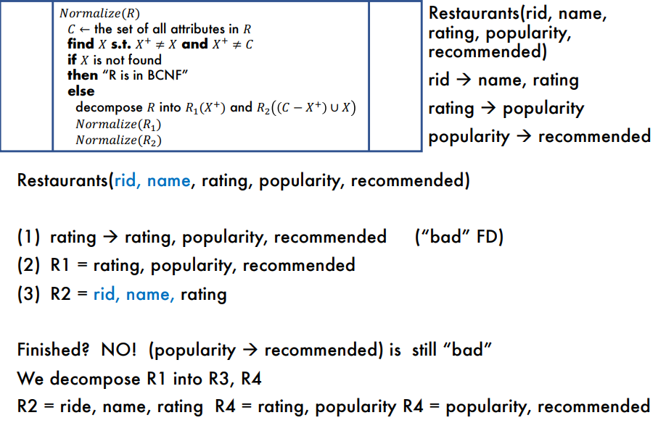

-GROUP BY and AGGs

-TABLES

-JOIN

-WHERE

-HAVING

-ORDER BY

-SELECT

-DISTINCT

Set Operations:

-SQL uses sets with duplicates(called bags)

-UNION: Combines 2 queries

-INTERSECT: intersection of 2 queries

-EXCEPT: Difference of queries

SQL subqueries

-Correlated Subquery: Subquery references outer table

-Decorrelated: no reference to outside tables

-Unnested: No subqueries

-Subqueries in Select returns single value and is reevaluated for each tuple in select statement

0 count cases are returned

Subqueries in WHERE

Existential quantifier: Indicates existence of at least one element(ANY/IN)

EX: Find companies that make **some** products…

Universal Quanitifier: Idicates a property of all elements(ALL/EXISTS)

Ex: Find companies where **all** products...

OR Find companies that make **only** product…

Monotonicity:

Adding tuples to input tables cannot decrease the size of the output

Queries without subqueries/aggs are always monotone

Select subqueries are usually monotone

Where subqueries and queries with aggregates may not be monotone

